PowerPoint Mix Tutorial

Office Mix Training Materials

Richard Treves

23rd June, 2016
First we’ll add a title slide and then a ‘traditional’ animated text slide.

1] Create a new PowerPoint

2] On the first slide give a title ‘Self paced Learning about Mental Health’

3] Add a new slide. In the title enter the text ‘Introduction’

3] In the bigger text box below it write the following text:
- Mind Map animation
- Activity 1: forum post
- Activity 2: show/hide question.

4] Block the main text and select ‘Animations (ribbon bar) > Fade (green star in the ‘entrance effects’ box). Then select ‘On Click’ in the bar top right of the screen.

You have just told powerpoint to make all the text fade in (hence green to start) line by line.

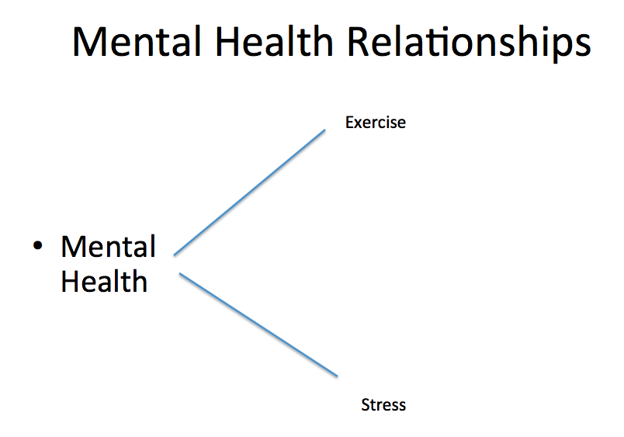

Animating Mind Map Slides
Now we’re going to create a slide like the one above and have that animate too.

5] Produce a new slide. Give it the title ‘Mental Health Activities.

6] Click in the other text box on screen. Drag the blue corners until the box is much smaller and is half way down the screen close to the left hand side of the screen.

7] Click in it and add ‘Mental Health’

8] Now draw a connector line: Home (ribbon button) > Shape pulldown > line > click and drag to draw a line from the text mental health upwards

9] Add another text box (Home (ribbon) > Text > text box > click at the empty end of the line. Type ‘Exercise’.

10] repeat steps 6 to 8, adding another line and another text box with ‘Stress’ in it.

Now we’re going to animate the text and lines to appear as we click.

11] Click the ‘Animations’ ribbon button.

12] Click mental health text so it becomes selected. Find ‘Fade’ under entrance effects

13] Now click the line between mental health and exercise. Blue blobs will appear on its ends to show its selected.

14] Click the same ‘fade’ button.

Q 15] You will notice that two numbers have appeared on screen, what do you think they do?

16] Now add fade animations to the ‘exercise’ text, the other blue line and the text ‘stress’ in the same way.

17] Save your PowerPoint. Test it PowerPoint by presenting it. You should see that your animations appear one by one.

Q18] Do you think the mind map is worth the extra work? Justify your answer with a couple of lines of comment:

Sometime you will want to edit one of your animations e.g. to add something in the middle. We will now learn how to edit a sequence

19] Click Animations (ribbon) > Reorder (button far right). A dialog will appear.

20] This lists the actions that will occur on screen in order. Practise moving elements up and down in the list and see what happens. You can also delete or add something.

21] Observe that this changes the numbers on screen that tell you the order of the animation.

Audio Narrative
Now we will add audio narrative to the slides.

16] click Mix (ribbon button) then ‘slide record’. Your slide will now open in a window with a black border.

17] Speak into the computer, they microphone line should show sound (mid right of screen). If not then choose a microphone from the pull down list to get it to work.

18] Click the red circle ‘record’ button. Dotted lines appear around the screen and your audio will be recorded. If the slide has no animations, you simply talk and it gets recorded.

If your slide is animated then you click the stars on the top bar to step through the animation recording as you go. When finished click the ‘stop’ button.

19] Preview your recording using the ‘preview slide recording’ button. If you aren’t happy , go back to step 18 to re-record.

20] If you’re happy, click the ‘next slide’ arrow and begin recording on a new screen.

21] Close (top left of screen) when you’re finished. Save your powerpoint.

Learning is most effective when students are active so its not advisable to record an hour long lecture.

Q22] What do you think a sensible length of video to split videos up into is? (separated by learning activities?)

Q23] What would make a good activity for students to do between videos?

Adding A Forum Question Slide
It’s sensible to add activity slides to an office mix. We’ll add one now.

24] Add new slide.

25] In the title type ‘Activity 1’

26] In the text slide add ‘Come up with three ways mental health can be improved and then post your thoughts in this Forum.

27] Highlight the text ‘post your thoughts to this forum’ then press CTRL + K. You should get a web link dialog.

28] In the new dialog enter ‘studynet.herts.ac.uk’ and click return.

29] This link will take them through to studynet. What you really want to do is create a forum post in Studynet, then collect the link from that and use it in place of ‘studynet.herts.ac.uk’

Adding a ‘show/hide’ Question Slide

We will now practice adding a simpler question, it poses a question then only gives the answer (or suggested answers) on the student clicking through.

30] Add a new slide, title it ‘Activity 2’ then in the main text type ‘Describe the benefits of exercise on mental health of someone recovering from mental illness. Click the slide to find out my thoughts.’

31] Add a new slide with a title ‘Answer’ and type in the main section ‘something about the positive effects of exercise here’.

Q32] What are your thoughts about the pros and cons of forum based and slide feedback based activities?

33] Save your PowerPoint.

Publishing your PowerPoint to Office 365

From this point on you could publish your PowerPoint to studynet and have students download and watch it. However, its better to upload it to office 365 as it can then be viewed via the web.

34] Go to studynet, login and access office365 (under ‘online services’ bottom right of screen). Annoyingly, you have to login again.

35] Access ‘OneDrive’. A list of files will appear on screen. Find your file via windows explorer and drag and drop it onto this screen.

36] When it has finished downloading, click it to open it with PowerPoint in the browser. It should work as in the PowerPoint program.

37] Now we want to share it with your students. Click ‘share with people’, in the box that opens choose ‘Get a link’ from the bar on the left.

38] From the dropdown menu choose ‘View Link – University of Hertfordshire account required’

39] Copy the URL in the link below. This can be posted to studynet and used by your students to access the PowerPoint.

